Infrared Robots in Physical Etoys

This tutorial deals with controlling robots with Physical Etoys. Now we have support for three robots: Robosapien V2, Roboquad and I-sobot. In this tutorial we will see that the way of controlling each of these robots is very similar, therefore, it will not be difficult if in the future we add more robots.

Necessary tools:

- An infrared transmitter connected with the computer. We will use the Lego IR serial tower.

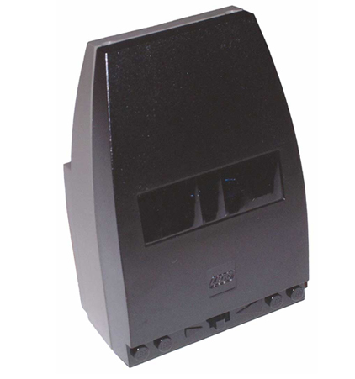

- Whichever of these robots: Robosapien V2, Roboquad or Isobot.
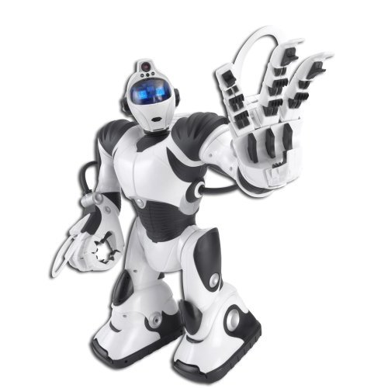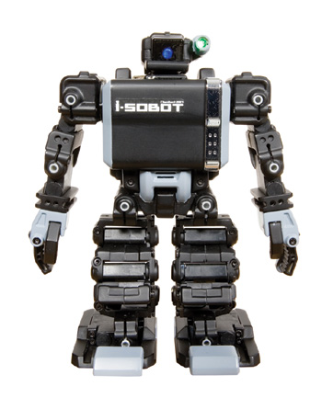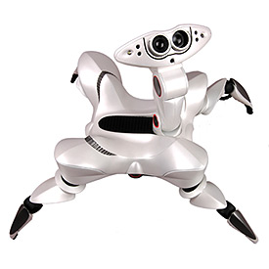

- Physical Etoys Software.

Connecting the infrared tower:

The first step is to connect physically the Lego IR serial tower with the computer’s serial port. You will not have problems because it is a “plug & play” device. As you can see in the following picture, the majority of the PC’s only have one serial port. By default, the assigned port that the serial port has is number 1.

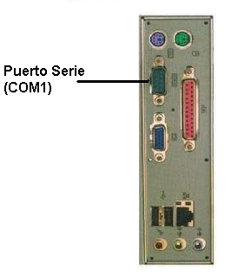

In case the computer does not have a serial port (like laptops) you can use a plug & play serial/USB adapter.
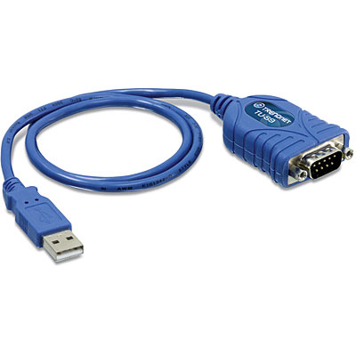
These adapters let us connect serial devices like our Lego IR transmitter on the USB port. However, it is important to take into account that the assigned port numbers will depend on the OS. If you want to know the port number you have to go to:

Control panel→system→hardware→device manager.

Next you have to look for the Serial/Usb adapter and its corresponding port.

Controlling Robosapien:

Now that Etoys is opened the first step is to obtain a “Robosapien”. This is a graphical object which represents the Robosapien. In order to obtain it we have to open the supplies’ flap.

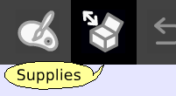

The supplies’ flap contains the most used objects. As long as we use the system we are going to learn more things about them. The one that interests us is the “Object catalog”.

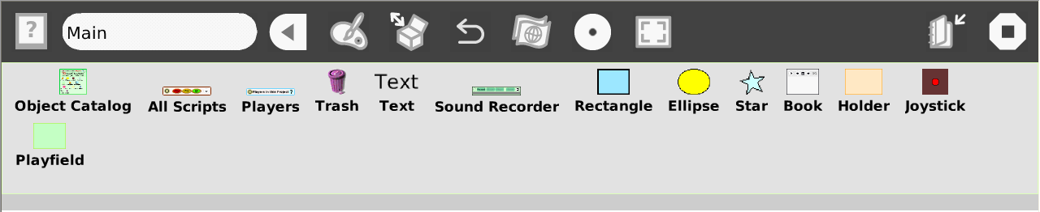

Now we have to drop the object catalog on the world.

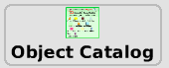

The object catalog is like a box that contains the entire objects that we can use. It is ordered by categories but we can arrange the objects alphabetically. Apart from that we can look for a particular one. Now we have to choose the IR Robots category. Then we have to drag the Robosapien etoy and place it on the world.

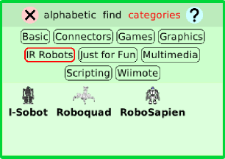

In order to connect the “Robosapien” we have to open its halo by right-clicking the “Robosapien”. The halo is a set of buttons which surround the object and let the user modify, move, delete and maximize it. The Robosapien is divided into different parts so we will open its center halo. When the cursor is over the correct zone the Robosapien’s outline will become light blue.

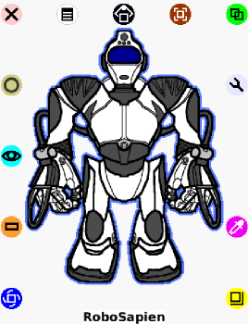

Next we click on the viewer icon (the one that looks like an eye) to make it appear.


The viewer is a flap where we can not only see and modify the object’s properties on the screen but also create scripts for them to perform actions like moving on the screen. The properties and the actions are represented as tiles.

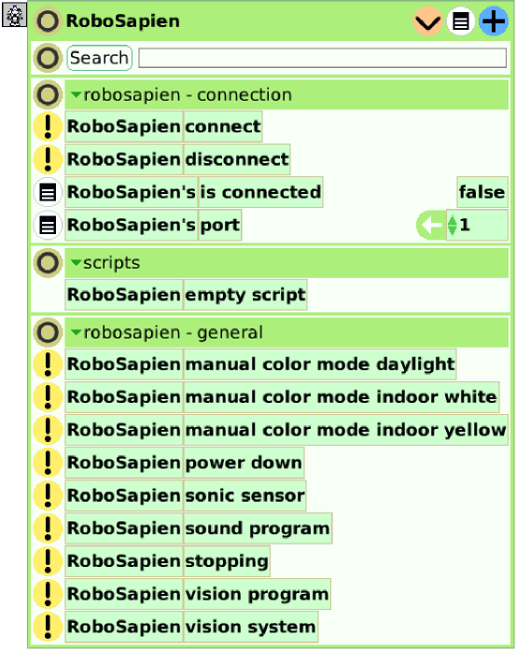

Now we have to turn on the real robot.
The important instruction is “connect” but, previously, we have to specify the port number of the Lego Tower. By default the number is 1 but it can change it if an adapter is used. If we run the instruction (by clicking on the yellow button with an exclamation sign) the robot will be ready to receive orders. Apart from that, the tile “is connected” will be true.

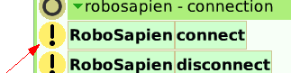

If we go to the other categories like “Robosapien – sounds”, we will see that there are more orders to send to the robot. We can run, with the robot turned on, the “laugh” instruction to see the Robosapien laughing. It will also indicate that everything is working properly.

Controlling the Roboquad:

As we did with the Robosapien, we have to go to the object catalog. Next, inside the “IR Robots” category we choose the “Roboquad”. Then we open its halo to go to the viewer.

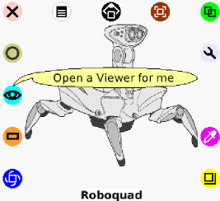

Take into account that the real Roboquad must be turned on. After the assignment of a port we have to run the connect instruction.

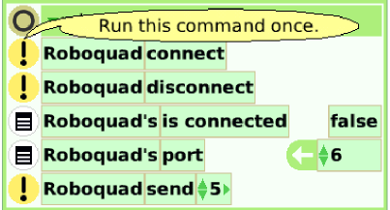

If everything functions properly, the value of the “isConnected” tile will be true. Now that the Roboquad is connected we can run whichever instruction of its.

Controlling the I-sobot:

As we did with the Robosapien, first we have to go to the object catalog. Next, inside the “IR Robots” category, we have to drag & drop the “I-sobot” onto the world. Then we open its halo to go to the viewer.
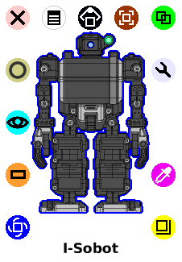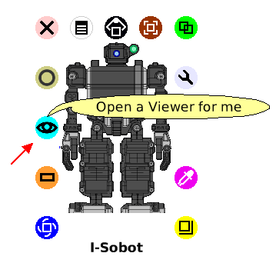
Take into account that the real I-sobot must be turned on and, as opposed to the previous robots, it has two channels for receiving the messages (A and B).

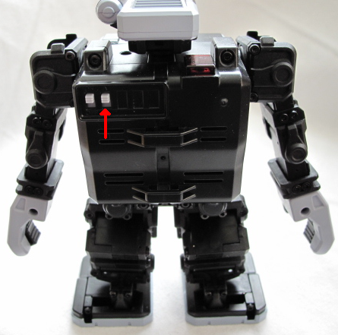

In order to define the channel that we will use, we have to change the value of the “channel” tile.

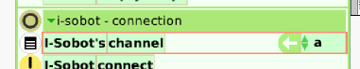

Once everything is correctly configured, we have to run the “connect” command by clicking on its exclamation sign.

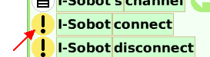

If everything has been OK, the “isConnected” properly will have a true value.



Now the I-sobot is connected we can run whichever instruction of its.

Conclusion

Well, that is basically all that we need to begin using IR Robots. The possibilities of interaction between the computer and the robots that Physical Etoys provides are very numerous to deal with everyone in this small tutorial. We encourage you to discover the other ones by exploring the environment (testing, playing, touching and breaking if it is necessary)

Have fun!

